RDC Linux SocketCAN Driver Usage

RDC Semiconductor Co., Ltd
http://www.rdc.com.tw
TEL: 886-3-666-2866
FAX: 886-3-563-1498
Revision History

Rev. | Date | History
REV. 1.0 | 2014/4/10 | - First version.

RDC reserves the right to make changes without further notice to any products or data herein to improve reliability, function, or design. Information furnished by RDC is believed to be accurate and reliable. However, RDC does not assure any liability arising out of the application or use of this information, nor the application or use of any product or circuit described herein, neither does it convey any license under its patent rights nor the rights of others.
Copyright © 2013 RDC Semiconductor Co., Ltd. All rights reserved.
      - Linux Software Installation
This is a RDC CAN Controller driver package.
RDC CAN module is based on SocketCAN device interface.
There are 3 device models: PCI model, Platform model and PNP model.
The first version can be used in Linux kernel 3.5.0 or later kernel 3.5.X version.
- Linux SocketCAN Driver Installing Procedure
Step 1: Before user install RDC SocketCAN driver module, user should check the Linux kernel had supported the SocketCAN driver modules (Please refer to Figure 1, 2, 3)
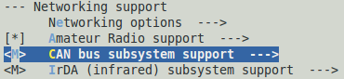
Figure 1
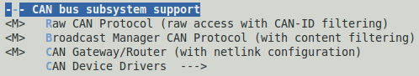
Figure 2
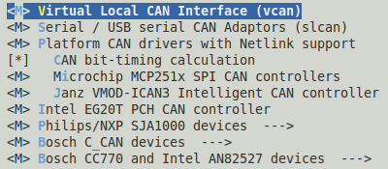
Figure 3

Step 2: Decompress the tarball “RDC_SocketCAN_Module.tar.gz”
Step 3: Type “CD” to the directory containing the package’s source code and type “sudo make clean | make all” to compile the package.
Step 4: You can type “sudo sh insmod_RDCCAN.sh” to install the RDC SocketCAN driver module. Please refer to Figure 4.

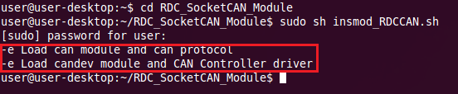
Figure 4

Step 5: You can type “dmesg” to check the number of CAN boards and channel. Please refer to Figure 5.
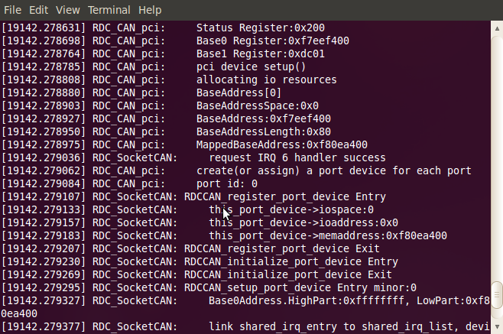
Figure 5

You can load different RDC CAN device model, SocketCAN module and protocols by modifying insmod_RDCCAN.sh.
- Startup and Stop SocketCAN Interface
Step 1: You can type “sudo sh ipup_RDCCAN.sh” to config CAN baud rate and startup CAN interface, and type “ifconfig” to check CAN interface. Please refer to Figure 6.
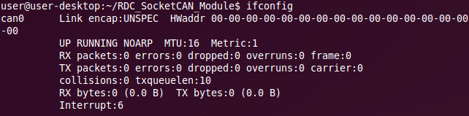
Figure 6

Step 2: You can use the “ip” command to check CAN interface status. Please refer to below command and Figure 7.

#sudo ip –d –s link show can0
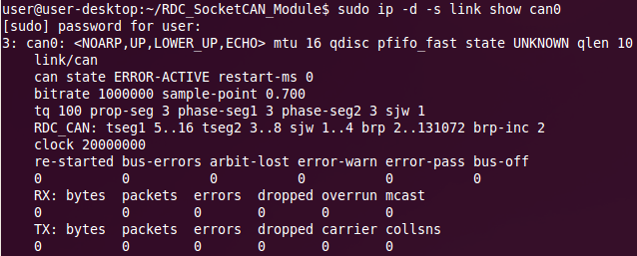
Figure 7

Step 3: If user want to stop CAN interface, user could type “sudo sh ipdown_RDCCAN.sh” to stop CAN interface.

You can config different CAN parameter by modifying ipup_RDCCAN.sh.

- Linux Driver Uninstalling Procedure
Step 1: Type “CD” to the directory containing the package’s source code.
Step 2: Type “sudo sh rmmod_RDCCAN.sh” to remove the SocketCAN driver module. Please refer to Figure 8.
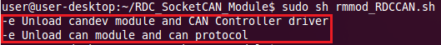
Figure 8

